The northern lights is one of the most naturally occurring aesthetics that can be experienced residing on Earth. Scientifically known as the Aurora Borealis, this phenomena happens in various countries around the world at certain times of the year. It is a beautiful sight to see, that I one day I might see for myself. National Geographic names the best places to see the northern lights. A few of those places are Iceland, Alaska, Canada and Norway. (<https://www.nationalgeographic.com/travel/top-10/7-aurora-destinations/>) There are excursions and vacations centered around the chance to see the beauty of the northern lights. It is most interesting to be able to visualize such a beautiful phenomena as I imagine this is a small part of the beauty that is seen by an astronaut in space.

It is interesting to note that this phenomena came into its name by way of a simple metaphor being made by Galileo in a second article of the collection, *Discourse on the Comets.”* This article was published under the name of Mario Guiducci, but was immediately recognized to be mostly the work of Galileo. Galileo at the time was under caution from the Catholic church to abandon the Copernican theory of heliocentrism, thus using his pupil as the messenger.

The first appearance of the northern dawn metaphor: ‘ And I know Academicians, that many of you will have seen more than once the sky at nighttime illuminated in its northern (settentrione) parts in such a way that its brightness yields nothing to the brightest dawn (aurora) and closely rivals the sun – an effect which in my opinion has no other origin than that part of the vapor-laden air surrounding the earth is for some reason unusually rarefied, and being extraordinarily sublimated has risen above the cone of the earth’s shadow so that it’s upper parts are struck by the sun and made able to reflect its splendor to us, thus forming for us questa boreale aurora (this northern dawn)’**2.**

So what is the aurora borealis as we know it now as a phenomena, as Galileo mentioned in his article very subtly it appears to be an interaction between the sun, vapor-laden air and the earth’s atmosphere. It is in other words just that. The aurora borealis is a product of interactions that are happening in the earth’s magnetosphere due to solar wind.

The earth resides in a magnetic cavity called the magnetosphere. A magnetosphere is the area of space, around a planet, that is controlled by the planet’s magnetic field. The shape of the magnetosphere is due to the push of the solar wind. The solar wind is made up of a gas of charged subatomic particles continuously flowing from the sun. Due to the solar wind’s inability to easily penetrate the earth’s magnetic field, instead it pushes on the field stretching it out into extending from the earth into interplanetary space Fig 1.**3** This shape formation is referred to as the magnetotail and this is the origin of the process that gives us the beautiful display known as The Northern Lights.

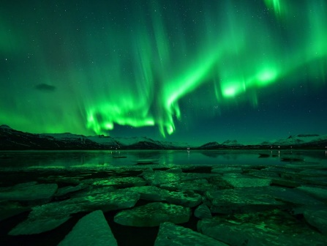

Figure 1 Jökulsárlón Glacier Lagoon,Iceland saravutpics/Shutterstock

The magnetotail consists of adjacent halves called lobes, which have opposing magnetization. In the upper lobe the magnetic field points sunward and the field lines connect to the north polar region of the earth. In the lower lobe, the field lines connect to the earth’s south polar region. The two lobes are separated by a sheet of electric current that flows across the midplane of the tail and then loops around to the north and south lobes. These loops of current create the magnetic fields in the lobes. Some solar-wind plasma will penetrate the magnetosphere’s sunward region and will populate on the surface regions of the tail. The plasma then flows through the lobes toward the midplane of the tail, where it forms a concentration of plasma called the plasma sheet. The plasma sheet is the site of current separation.

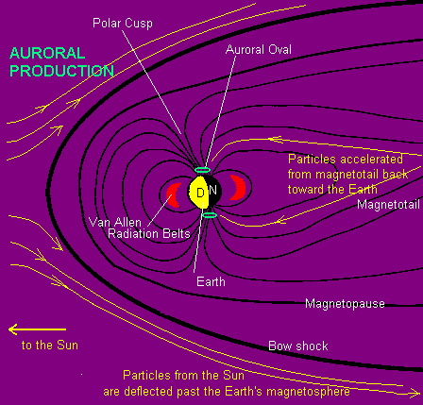

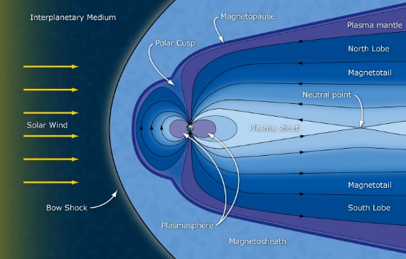

The interactions of charged particles, electric currents, electric fields and magnetic fields all sustain the magnetotail. We can look at these in parts. The charged particles are acted on through the Lorentz Force.

$$\vec{F}=q\vec{E}+q\vec{v} x\vec{ B}$$

The second interaction of a charged particle is called the E-cross-B drift. The Lorentz force gives us the trajectory of the charged particles of plasma from the solar wind, drift adds extra motion. When an electric field is imposed perpendicular to a magnetic field the spiraling particles tied to magnetic field lines experience a drift perpendicular to both the electric field, $\vec{E}$, and the magnetic field, $\vec{B}$**.**

$$\vec{v_{d}}=\frac{c{\vec{E}}_{0}x{\vec{B}}_{0}}{B_{0}^{2}}$$

If the magnetic field becomes weak or changes sharply, the plasma and field lines no longer move in tandem. The field lines of opposite direction will come together, break and reconnect. This can be referred to as Magnetic Reconnection. Magnetic Reconnection is important explains the energy releases that characterize solar flares and auroral brightenings called auroral or magnetospheric substorms.**5** The Magnetotail has three types of field lines: open field lines (found in the lobes); closed field lines (found in the plasma sheet) and interplanetary field lines (found in the plasma sheet downstream from the magnetic neutral line). When magnetic reconnection happens along with the solar wind interacting with the magnetosphere magnetohydrodynamic, (MHD), generator behavior is created.

The magnetohydrodynamic process generates electricity at two locations, the more important location being sunward limit of the magnetopause. Electricity is injected into the Earth’s magnetic field resulting in electric current that stretches the earth’s field lines.**5** The stretching results from an electromagnetic phenomena called the J-cross-B force. During the increase of energy and stretching a new neutral line is formed and disrupts the current that normally crosses the plasma sheet. The current is suddenly reduced, and the magnetic field lines in that particular region suddenly “collapse” toward the earth. This collapse rains electrons into the upper atmosphere, producing auroral lights. This new neutral line can remain for up to two hours as the site for reconnection of field lines which will continue to cause bright auroras. **3**

Let’s summarize simply what happens that gives us this beautiful tango of light. The magnetotail is the origin and source of the auroras. Magnetotails occur in our solar system. They are formed wherever a planetary body has an intrinsic magnetic field (Earth, Jupiter, Mercury and Saturn) or a body that has an electrically conductive atmosphere (Venus) embedded in a flowing magnetized plasma. Electromagnetic forces acting on the plasma and energy is stored in the form of stretched magnetic fields downstream of the body. There is also a release of energy that happens due to reconnection and can be released in the direction of the body creating auroras in the magnetosphere of the planet.

The study of the processes that happen in the magnetotail that build up and release energy continue to be studied. A major part of this study are the plasmoid that are formed which can be also be created in a lab and lend to the study of nuclear fission and plasma physics.

Author’s Note: Due to procrastination and life this is a very rough draft. All issues will be fixed that I am already aware of in addition to feedback.

Things to address:

1. Clarifying process taking place.
2. Better segways.
3. Label pictures.
4. Add remaining references.
5. Key terms lacking background information

**Bibliography**

1<https://www.nationalgeographic.com/travel/top-10/7-aurora-destinations/>

2Siscoe, G. L. (1978), An historical footnote on the origin of “Aurora Borealis”, *Eos Trans. AGU*, 59(12), 994–997, doi:[10.1029/EO059i012p00994](https://doi.org/10.1029/EO059i012p00994).

3Hones, E. (1986), The Earth's Magnetotail. *Scientific American,254*(3), 40-47, http://www.jstor.org/stable/24975910

4Dungey, J.W. (1961), Interplanetary Magnetic Field and the Auroral Zones. *Physical Review Letters,* 6(2), 47-48, doi:10.1103/PhysRevLett.6.47.

5Hones, E. (1985), Magnetic Reconnection in the Earth’s Magnetotail. *Australian Journal of Physics,* 38, 981-997

6<http://www.phys.nthu.edu.tw/~thschang/notes/PP02.pdf> - drift velocity E cross B